**Guideline iMEP**

Dear colleagues, to make work a bit easier, I've written a simple Word macro that automatically fills in the party (e.g., EPP) and country abbreviations (e.g., NL) of MEPs.

All you need to do is write the MEP's **surname** in capital letters, followed by **(XX/XX)**. After activating the macro, the rest of the information will be added automatically. However, it is important that you write the MEP's surname correctly; otherwise, the macro won't recognize it.

So, in short: After running the macro, WEBER (XX/XX) becomes WEBER (EPP/DE).

All best,

Chris VAN DE WEIJER

**How to add the Macro to Word?**

Below you will find a step-by-step explanation on how to add the Macro to Word, but I'm also happy to install it for you - just let me know.

**Step-by-step explanation:**

1. Under View, navigate to Macros and click on View Macros.
2. Type 'iMEP' and click Create.
3. You will open Microsoft Visual Basic for Applications and see the following script of the new macro you have created.

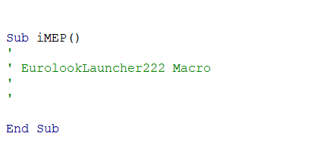

1. Now double-click the black box below to find the entire code and copy **the whole code**.



1. Paste it in Microsoft Visual Basic for Applications, overwriting the text you found in step 3. Note that you may see other text regarding another macro, e.g., '*Sub XXXXXX()*', but don't change this macro, only the iMEP macro.

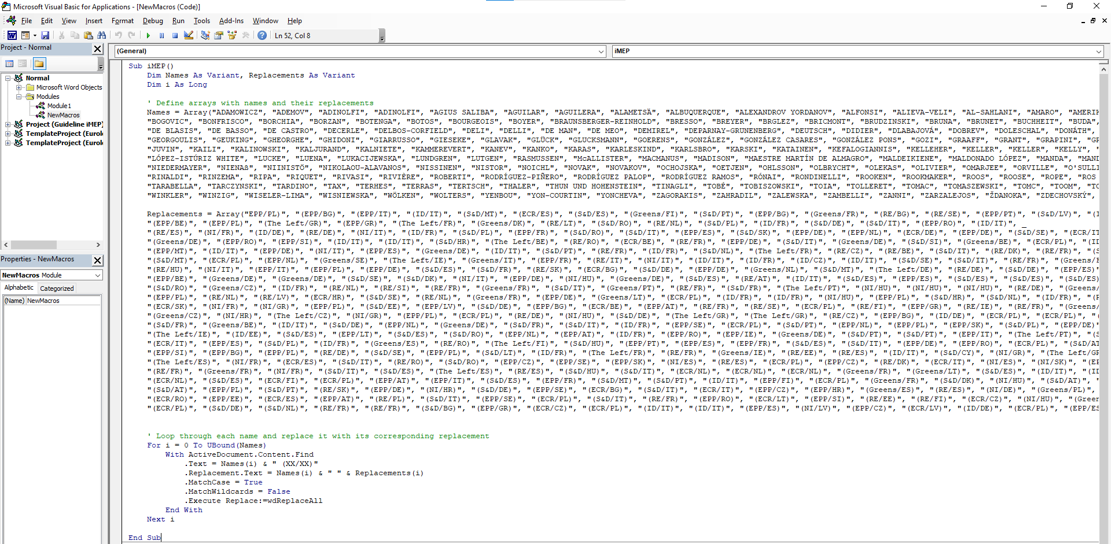

1. Click **Save Normal**

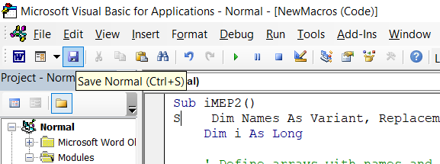

1. And **Close and Return to Microsoft Word**

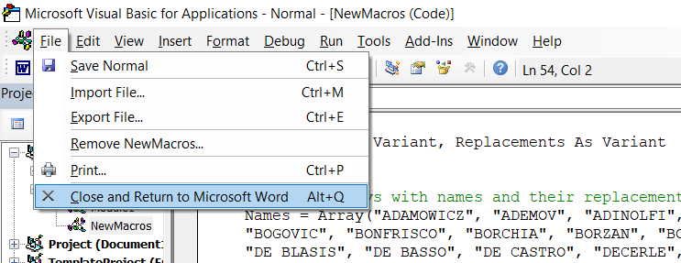

1. **Try it out!** Write your favourite MEP’s **surname**, followed by **(XX/XX)** and run the Macro by navigating to **Macros**-> **View Macros -> iMEP ->** Click **Run**

**Questions**

**What is it?**

It is a Microsoft Word macro that fills in the land & political information of MEPs (2019-2024).

**Is the data reliable?**

The data is extracted from the [EP’s own website](https://www.europarl.europa.eu/meps/en/full-list).

**Word blocks the macro[1], how can I fix this?**

Colleagues from IT services explained to me that macros from external sources or drives are blocked. To avoid this error message, you should save the file on the Commission’s shared drive (for example your shared U: Drive). Avoid sharing files with the macro on your personal laptop or personal computer drive. If the problem persists, please let me know or ask a colleague from DG DIGIT[2].

**Does it work perfectly?**

Word VBA has some limitations when it comes to certain letters and symbols. Luckily, letters can be replaced with their corresponding Unicode representations, allowing for accurate name replacements.

Names such as ŞTEFĂNUȚĂ (RE/RO), GYŐRI (NI/HU), MALDEIKIENĖ (EPP/LT), and ROTH NEVEĎALOVÁ (S&D/SK) **are** successfully replaced using their correct Unicode representations. It's important to note that the names must be written correctly, including the specific letters and symbols. For example, "STEFANUTA" will not work, but "ŞTEFĂNUȚĂ" will be recognised and replaced accurately.

If you find a name of a MEP that does not work, please let me know!

In the future, I plan to create a similar macro that can correctly rewrite all the names for you so that a STEFANUTA will be replaced with ŞTEFĂNUȚĂ.

**Wat if a MEP stops and I want to add the replacing MEP to the macro?**

The macro matches the values of **NAMES** and **Replacements** in sequential order, so the first name gets matched with the first value of country & party abbreviation. Therefore, you might have a hard time finding the 654th name and editing the related country and party abbreviation.

To add a new MEP, simply include the new name in the **Names** and **Replacements** arrays as the last value. The values should be in capitals between double quotation marks, and close the array with a closing bracket.

Similarly, if an MEP changes parties, my advice is to add new values to the **Names** and **Replacements** arrays and make the "old" value invalid. You can do this by changing the name of, for example, STEFANUTA (who changed from Renew Europe to the Greens in 2023) to 'STEFA_X_NUTA'.

**Any best practices tips?**

First, please always check if you have correctly spelled the surname of the MEP, as the macro might miss special characters. Second, after running the macro, please check your document by searching for 'XX' to ensure that you haven't missed any party or country abbreviations.

**How can I add the macro to my Word Quick Access Toolbar?**

1. **Go to File -> Options**

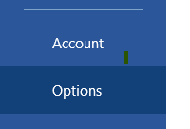

1. **Click on Quick Access Toolbar, and choose commands from Macros**

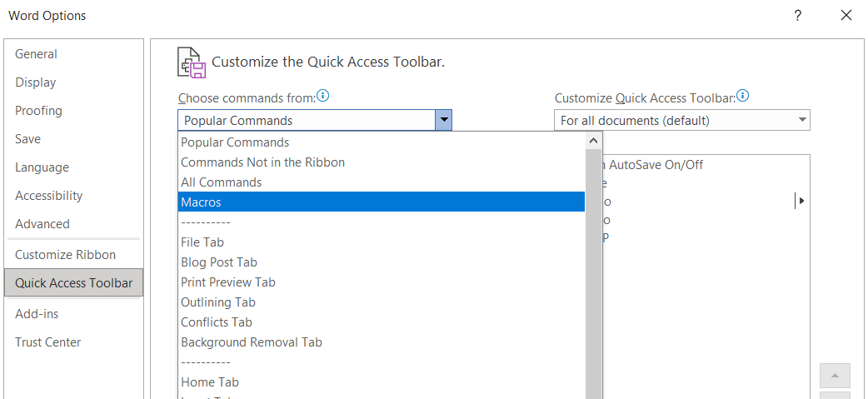

1. **Select ‘Normal.NewMacros.iMEP’ and add it to your Toolbar. You can modify the icon and name of the macro; I gave mine the ‘😊’ symbol.**

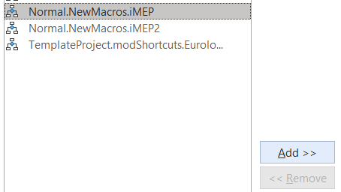

1. **Now you can easily click the macro to use it in your documents!**

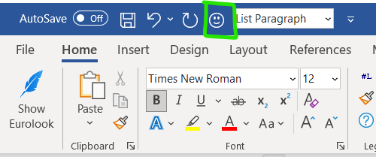

**What should we do with the macro after the elections?**

I'm happy to edit the macro after the elections, and if not, another colleague willing to do so can! 😊

**Other questions?**

Let me know!

1. You may for example encounter this message in Word: ‘Macros in this document have been disabled by your enterprise administration for security reasons’
2. Only contact DG DIGIT with general questions about unblocking macros in Word, they are not responsible for using the iMEP macro.